The RTK-Pro's walk back feature will lead the user to previously collected GNSS coordinates.

To use the walk back feature;
- Update the RTK-Pro's software using the MyLocator3 desktop app.
- Create an account in the VMMap Web Portal at https://vmmap.vivax-metrotech.com/login.

VMMap Web Portal
Add a Walk Back Point - Add the list of desired points into the VMMap web portal. These desired points will come from surveys already stored in the VMMap cloud and collected with an RTK-Pro receiver.

- The survey list opens a survey containing the desired point that would need to walk back to.

- Once the survey is open start from the "Map" tab.

- On the top left an option with a slider labeled "Display Walk Back" select this to toggle to view the map's points.
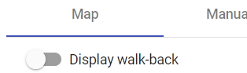

- The list of points collected in the survey job are displayed on a map similar to the below.
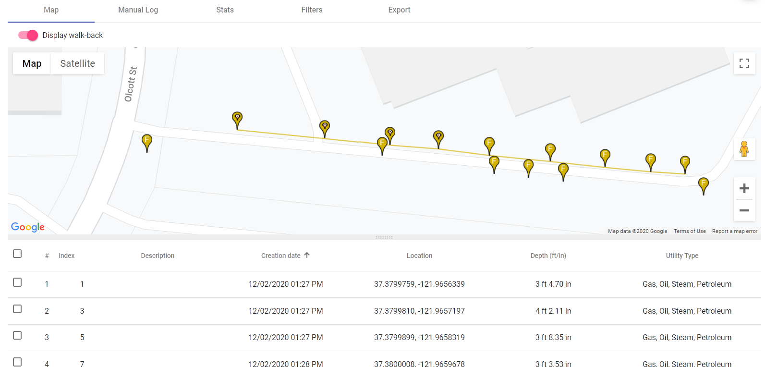

- Note the check box next to the number of points contained in the survey. Identify the point to be added to the walk back list and click on the check box.
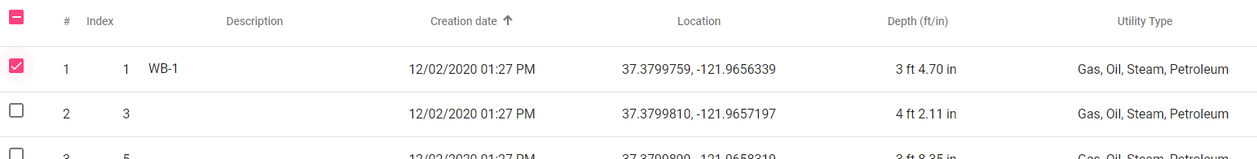

- When logs are selected, the letters "WB" will show beside them, and the map pins are temporally animated.
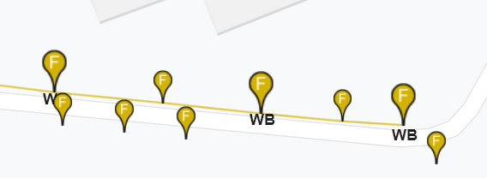
- Once the desired points are selected an automatic description is assigned. These descriptions can be edited if so desired.
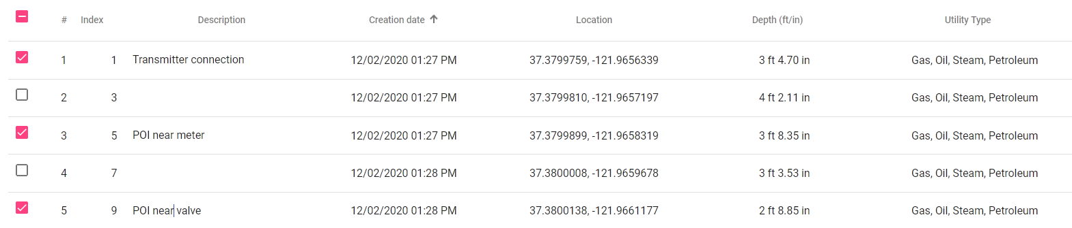

- When all the needed points are selected click on the "Add" option on the bottom left.
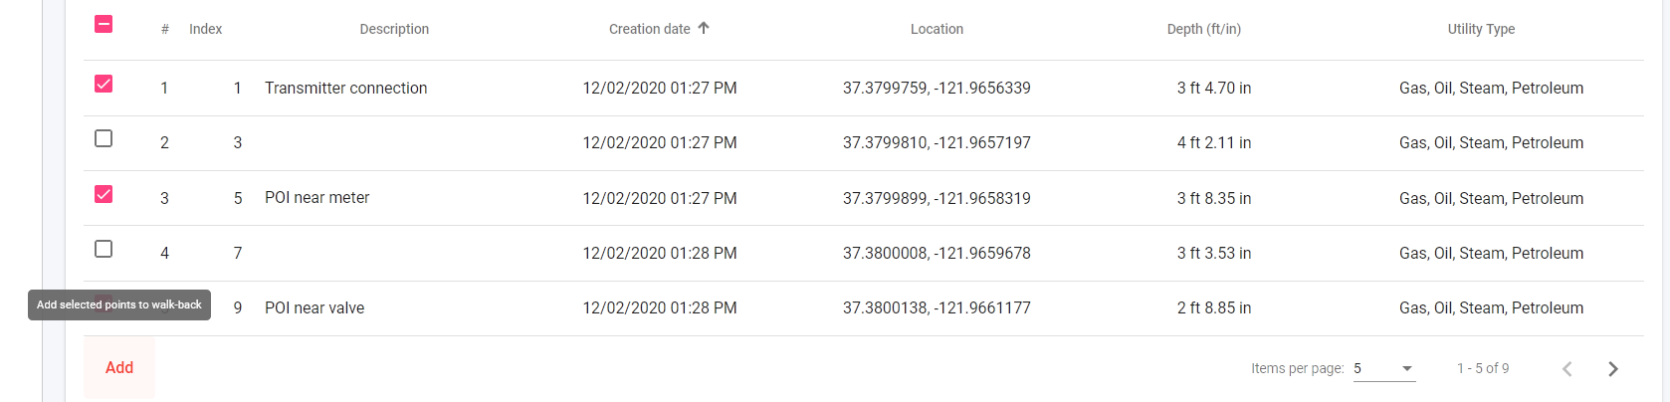

- A pop-up window will appear with the option of a drop-down with available RTK-Pro serial numbers. Select one or more serial numbers of receivers who would need the Walk Back points assigned. Click on the "Save" button.
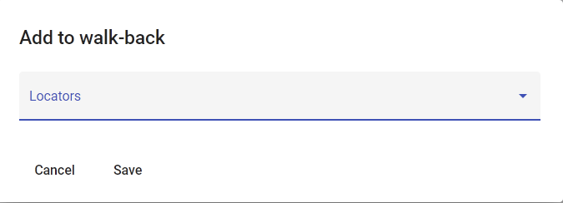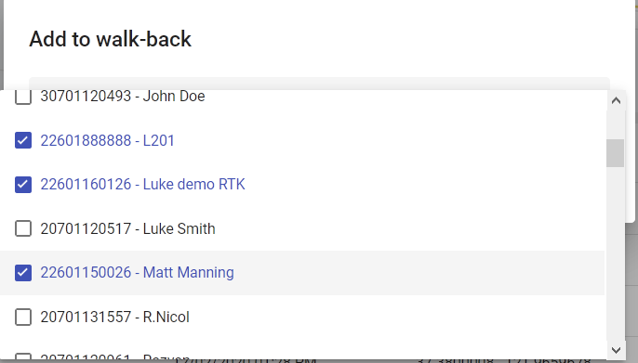

- To edit and viewpoints added to the Walk Back list go to the Walk Back tab.
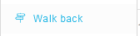

- Here an overview of the Walk Back points assigned to users within the company will be displayed with open or completed status.
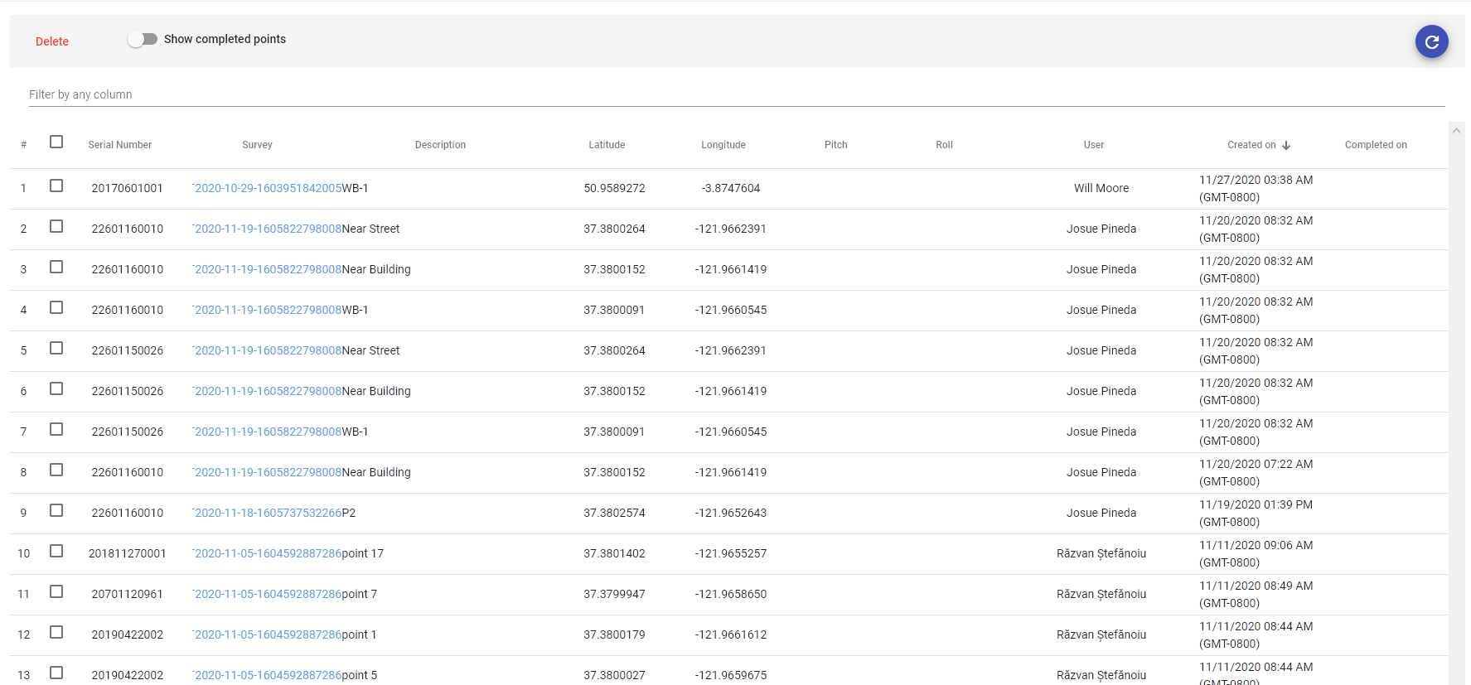

- To view completed Walk Back points toggle the "Show completed points" option.

Performing an RTK-Pro Walk Back
Now that the Walk Back points have been selected, the VMMap cloud uses the RTK-Pro receiver containing the assigned receiver serial number and Walk Back points.

- In the RTK-Pro menu navigate to scroll to Walk Back and enter the sub-menu option.
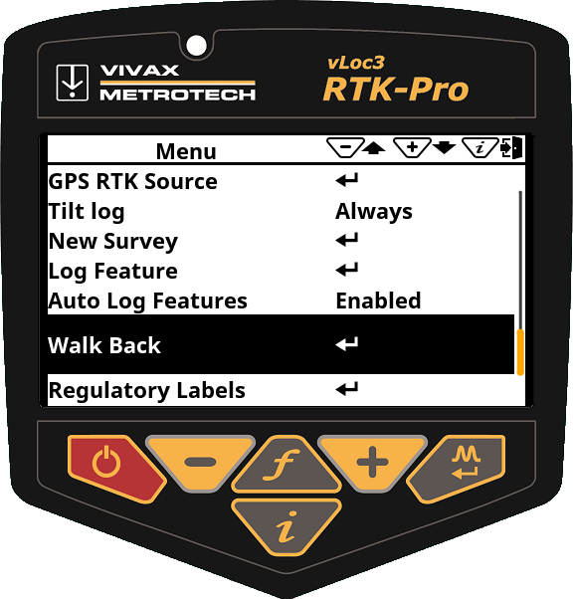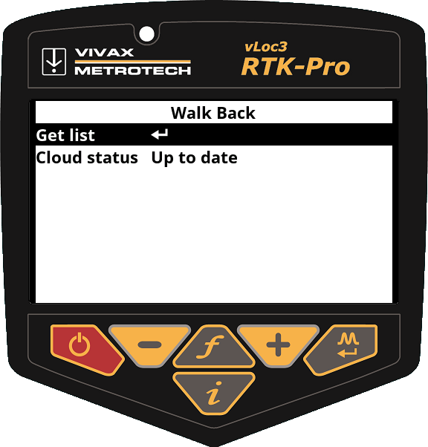

- At the Get list option and press the enter pushbutton to bring up the list of Walk Back points allocated to this receiver's serial number from the VMMap Cloud.
- Once the Walk Back points have been downloaded from the VMMap Cloud, they are displayed in a list by the Walk Back point description.  Scroll to the point needed to Walk Back to and click on the enter pushbutton. | 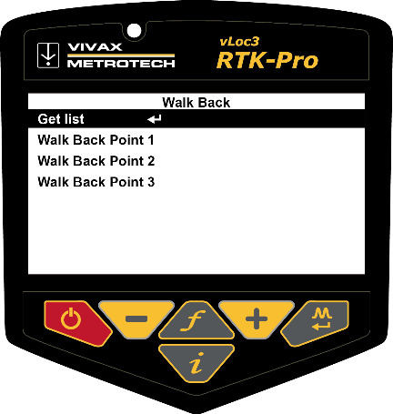
- Once the Walk Back point is selected a screen similar to the one shown on the right will be seen.  On this screen the following is displayed:  - Shows your current Latitude, Longitude and Altitude and horizontal accuracy in 2DRMS.  - Shows the horizontal distance from the locator GNSS antenna to the Walk Back point in the bottom right corner of the screen.  - When further from the Walk Back point and moving a guidance arrow points towards the Walk Back point. | 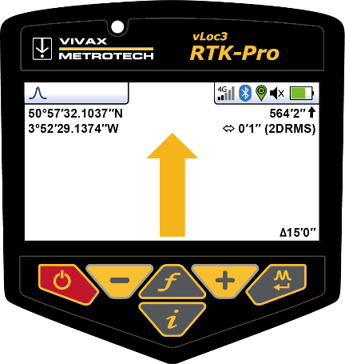

Note:
- The Guidance arrow assumes you are walking with the locator in front of you with the bottom of the screen closest to your body in the usual way
- When stationary, no guidance arrow is shown

- Follow the guidance arrow to get near the Walk Back point. Once within 10-feet (3m) a crosshair icon will be displayed. A spirit level is shown. The center of the spirit level represents the location of the GNSS antenna. You must maintain the locator's orientation and move forwards and backward, left and right, and not rotate the locator. | 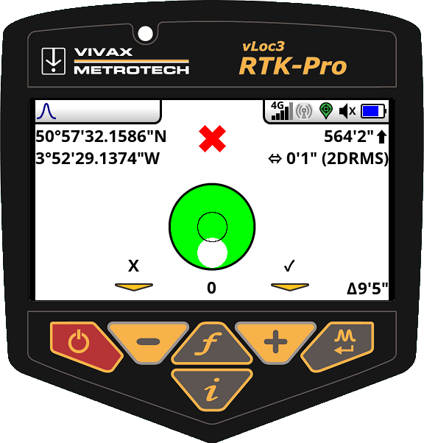
- As you walk toward the Walk Back point, you aim to get the red cross in the center of the spirit level. Now the GNSS antenna is over the Walk Back point. | 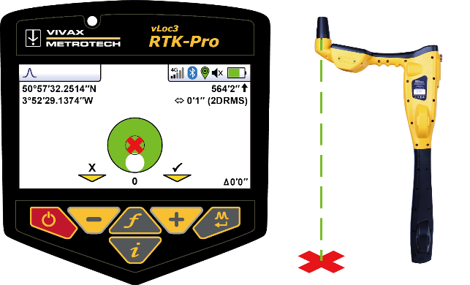
- As you tilt the locator to get the GNSS antenna over the locator's foot, you aim to get the spirit level bubble into the center of the spirit level. When you have the locator's foot on the ground, and the Walk Back point the red cross and the spirit level bubble will be in the center of the spirit level, as shown in the illustration to the right. | 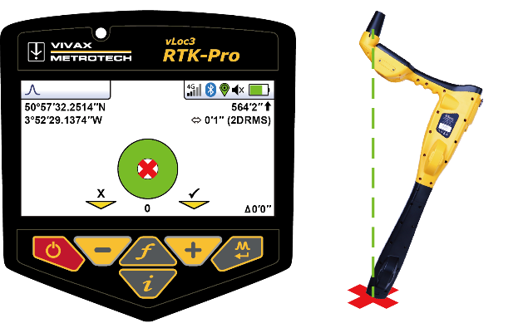
- Use the + key to log the Walk Back as complete. This records how accurately the Walk Back was performed and marks the Walk Back as complete in the VMMap Cloud.
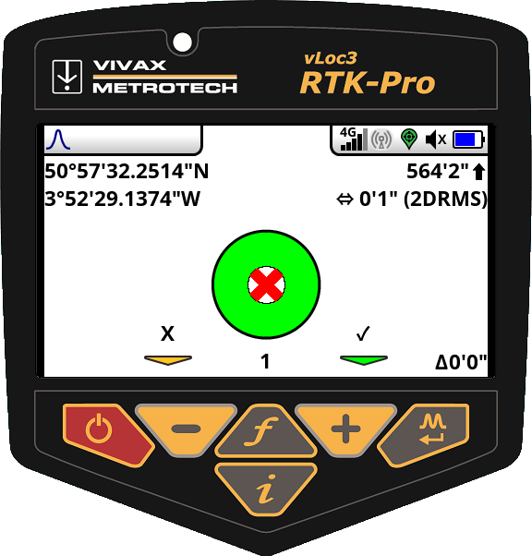
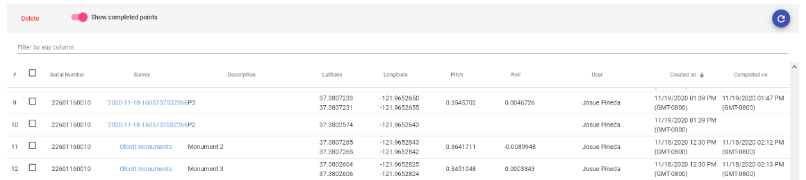

*Please note some screens and images have been simulated and do not represent the final product.

Vivax-Metrotech Corp. (Headquarter)
3251 Olcott Street, Santa Clara, CA 95054, USA
T/Free: 1-800-446-3392
Tel: +1-408-734-1400
Fax: +1-408-734-1415
Email: SalesUSA@vxmt.com
Website: www.vivax-metrotech.com

Visit us at www.vivax-metrotech.com to view our full product line and worldwide locations.

