Feature Logging is for collecting additional information on an underground utility or its surrounding above-ground point of interest.

Requirements:
- Microsoft Excel® (version 2008 and above with .xlsx format)
- MyLocator3 Desktop App (Available free of charge on www.vivax-metrotech.com/support/downloads)

Setup and Import of Data Dictionary
First, one must set up a data dictionary to easily tag the data collected during the locating survey. Below is the process of how to create and load the data dictionary into the RTK-Pro using MyLocator3.

- Setup the data dictionary with assigned definitions and code  - The definition is human-readable when the list is presented.  - The code is useful when filtering data when post-processing. | 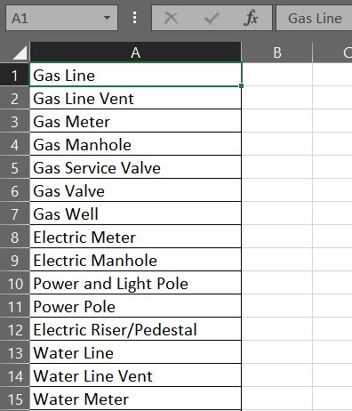  Colum A - Feature Definition
- In this example we will use Microsoft® Excel® to set up the data dictionary

- Start with a new document and single sheet.

- Two columns are required. One contains the “Definition” and the other a “Code” associated with that definition.

- The first column, “A,” will contain the feature definition as seen below. A maximum of 48 characters may be entered. The text entered here will be displayed on the RTK-Pro when the feature log list is presented to the user.

- In the second column, “B” enter a code associated with the definition. Using codes will make sorting or parsing data easier after the data has been collected. The below contains a maximum of nine characters. | 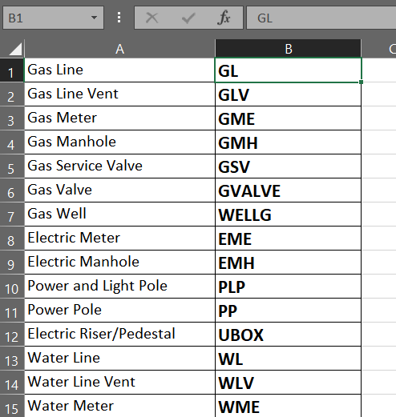  Colum B - Feature Code
- Continue to add feature definitions as needed with a maximum of 200.
- Continue to add feature definitions as needed with a maximum of 200.
- Save the file as Microsoft® Excel® Workbook (.xlsx) to your local storage drive.
- Open MyLocator3 and connect the RTK-Pro using the USB cable.

- Click on the tab on the left labeled “Feature Logging.”

- In the Feature Logging sub-menu, select the “Open” to select the .xlsx file created in the previous steps.
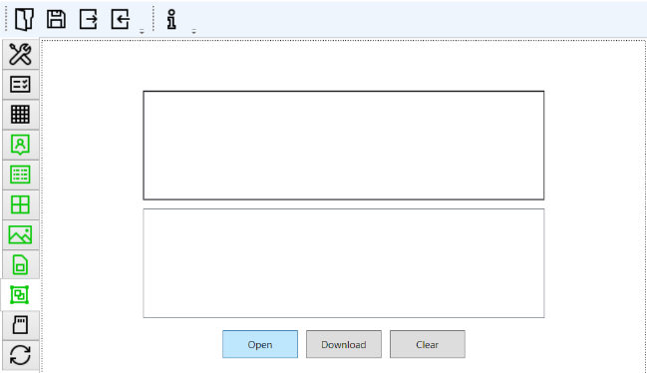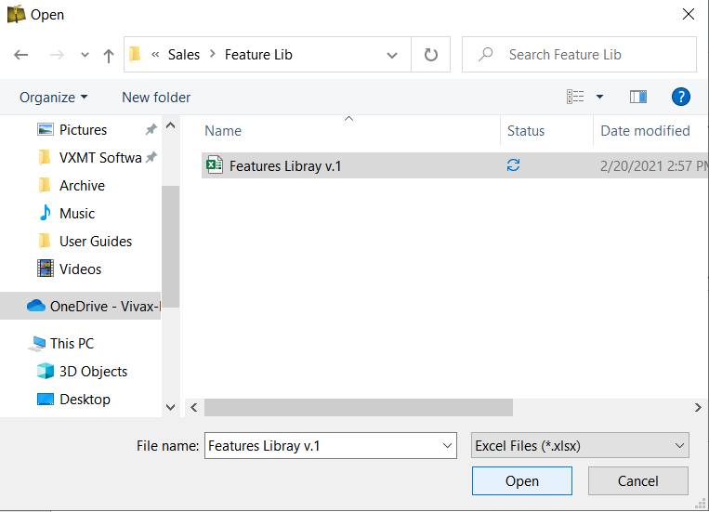

- Once the file has been selected a review of the containing features will be displayed by pressing the small triangle next to “Feature Definitions.”

- Now select “Download” to download the data dictionary into the RTK-Pro receiver. | 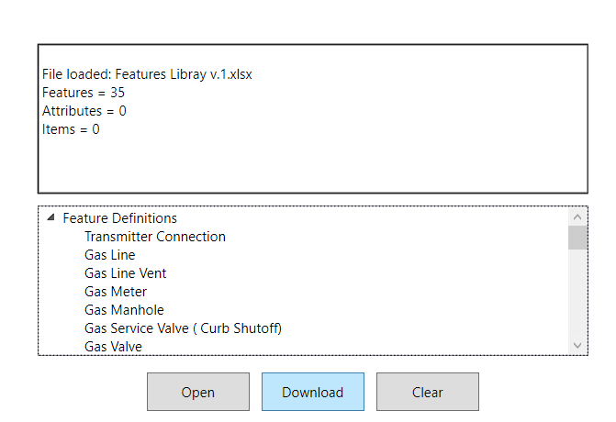

- Power off the unit, so the changes take effect. At the next power-up the data dictionary will be available in the receiver.

Logging Features
To collect a feature, enter the main menu and scroll to the “Feature Log” menu option.

There are two ways in which feature logs operate:
- The first method is labeled as “Log Feature” in the main menu.
- The second method is labeled “Auto Log Feature,” which is also found in the main menu.

We will first cover the Log Feature to collect points of interest that do not carry a locating signal tone.
For example, a handhole cover is present but not part of the underground utility.

Logging Feature:

- Place the RTK-Pro on the point of interest.  - Long press on the “i” key to enter the main menu and scroll to Log Feature  - Once entered, the info-screen appears. Press the “f” pushbutton to open the data dictionary list with all the available definitions.  - Use the “+” and “-“ pushbuttons to scroll the list. Once the required feature is reached, press the “Return” pushbutton. | 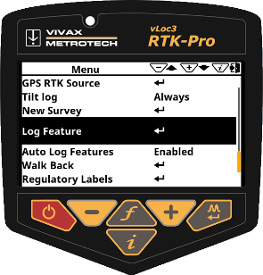  Scroll to Log Feature

- Press the “+” pushbutton to log. Now the receiver will display the spirit level to tilt the receiver to align the GNSS antenna.
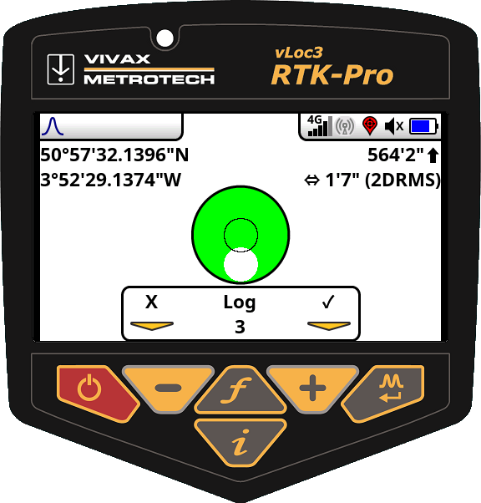  Spirit Level is displayed | 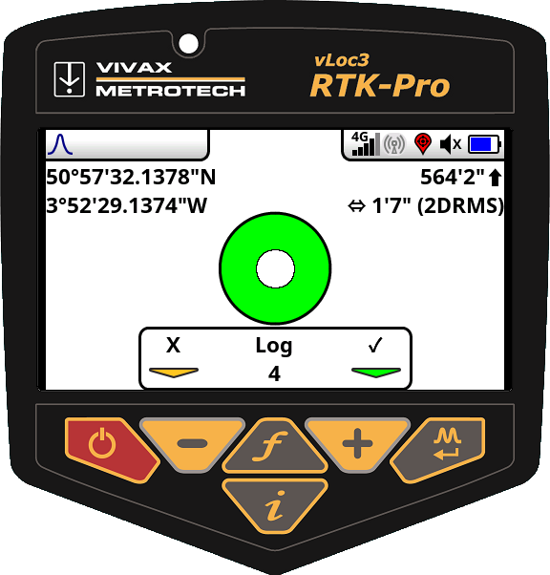  Aligned GNSS Antenna

Auto Log Feature
To enable the Auto Log Function, navigate to the main menu and find “Auto Log Feature.” Two options are presented to the user Enabled or Disabled. Enabling this option will tag all the logs with a specified feature. Enabling the Auto Log Feature options helps with tagging data on the underground utility that will need to remain the same for more than one log. Leave the user menu by pressing the “i” pushbutton.

To collect data with the Auto Log Feature enabled perform the following:

- Locate the underground utility.  - Enter the information screen by pressing the “i” pushbutton.  - Press the “f” pushbutton to display the list of available features in the data dictionary.  - Use the “+” and “-“ pushbuttons to scroll the list. Once the required feature is reached, press the “Return” pushbutton.  - Use the “+” and “-“ pushbuttons to scroll the list. Once the required feature is reached, press the “Return” pushbutton. | 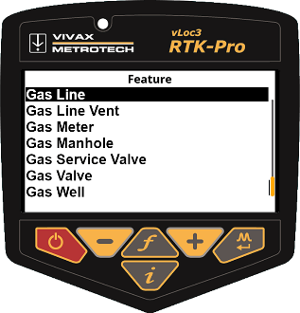  List of Available Features

- Once the selected feature is selected, the screen will change to the tilt screen to align the spirit level to store the log.
Spirit Level is displayed | Aligned GNSS Antenna

- The screen will now revert to the locate screen. Now you can continue to locate the utility. Continue to collect data as needed. If the feature needs to be changed press the “f” pushbutton to open the data dictionary.

Tip:
From the moment the automatic object recording is activated, every point recorded is provided with a feature. If you no longer want this, switch off the “Auto Log Features” recording in the main menu.

Feature Logs in VMMap Cloud
Once feature logs are synced with the utility survey in the cloud, a unique pin is assigned. The example below shows the location pin is brown; it also contains an “F” label.
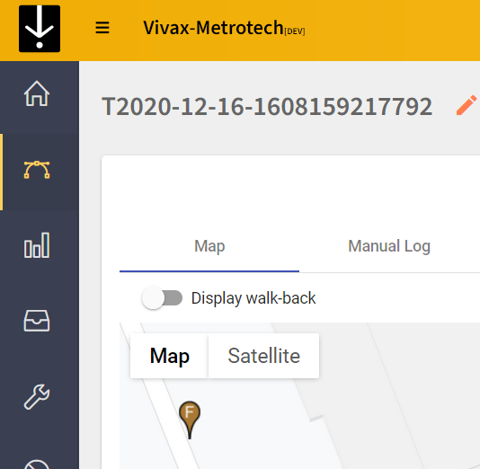
Location Pin

When exporting the data to a .csv or .shp file, the feature log data is also carried over. Below you can see the column labeled “Feature Code” and “Feature Description.”
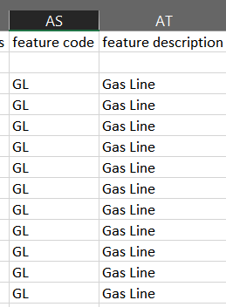

All third-party trademarks belong to their respective owners.

Vivax-Metrotech Corporation
3251 Olcott Street,
Santa Clara, CA 95054, USA

T/Free : 1-800-446-3392
Tel : +1-408-734-1400
Fax : +1-408-734-1415
Email : SalesUSA@vxmt.com
Website : www.vivax-metrotech.com

